**Reviewed by Austin (Tzu-Hsun) Lin**

**1-Problem Description**: Alt-text does not fully describe the image context

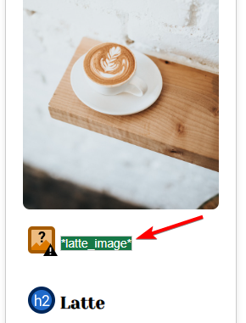

**POUR Principle Applicable**: Perceivable

**User Impact**: Visually impaired user can not fully grasp the image context when using screen readers.

**Recommendation**: Remove “_image” and provide more descriptive alt-text. For example, the image above should be “latte topped with floral milk foam in a white cub” instead of “latte_image”

**2-Problem Description:** Accordion buttons look like just plain text, and do not give any indications that it could be clicked to reveal more information.

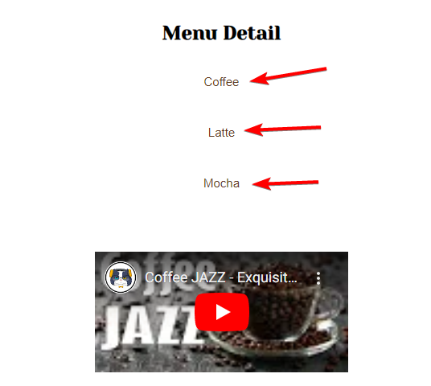

**POUR Principle Applicable:** Perceivable

**User Impact:** Users will not know these are clickable to reveal more information unless they happen to hover the mouse cursor over them. For touchscreen devices, it’s even harder to find out, because there is no mouse to hover with.

**Recommendation:** Make these look like buttons and/or have icons to hint they are clickable.

**3-Problem Description:** For the same 3 accordion buttons mentioned above, when using the keyboard TAB to navigate to those buttons, there is no visual cue to indicate the button is in focus

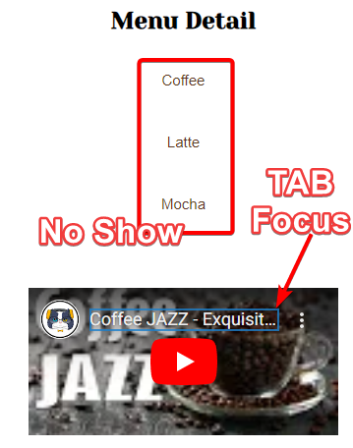**POUR Principle Applicable:** Operable

**User Impact:** For users who can’t use a mouse and must rely on a keyboard to navigate, they can’t tell if any of the accordion buttons is selected.

**Recommendation:** Change the accordion button’s outline and/or background color

**4-Problem Description:** The footer Google Map <iframe> does not have a title

**POUR Principle Applicable:** Perceivable

**User Impact:** Visually impaired users who rely on screen readers would not know the contents of the frame.

**Recommendation:** Add a title to the <iframe>

**5-Problem Description:** For the footer’s Quick Link, only the icons are clickable with links, the words (Home, Menu, Instagram…) are not, which is against conventions.

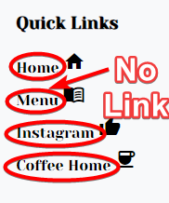**POUR Principle Applicable:** Operable

**User Impact:** Users might think the link is broken, and thus not operable.

**Recommendation:** make the words also clickable as the icons.